Computer Science TELEPORTER ACTOR Lab Value - 100

Lab Goal : This lab was designed to teach you more the GridWorld case study and more about the methods of the Actor class.

Lab Description : Extend the Actor class to make a TeleporterActor that will more from its current spot to any open spot in the grid. You must generate random locations. You will need to use the Math.random() method. TeleportActor cannot move to an occupied cell and must not attempt to move to cells outside the grid.

Files Needed ::
TeleporterActor.java
TeleporterActorRunner.java
GridWorld Project

Sample Data :
none

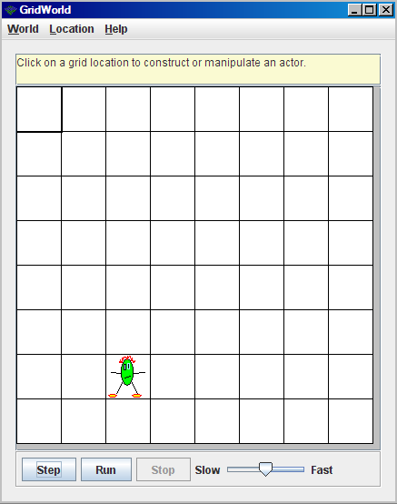
Sample Output :
